Arctic Melon Pops
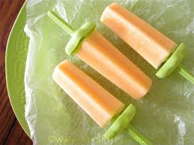
2 Cups cut-up cantaloupe (½ of a medium melon)
1 Small banana, cut up
1 6oz can frozen orange juice concentrate
¼ cup nonfat dry milk powder
½ cup lemon-lime carbonated beverage
1 8oz. carton orange or lemon yogurt

In a blender container combine all ingredients. Cover and blend till smooth. Pour into eight 5-ounce paper cups. Cover each cup with foil. Make a small hole in the foil with a knife. Insert a wooden stick into the cup through the hole. Freeze for 4-6 hours or till firm. To serve, remove foil and peel off paper. Makes 8 pops. 112 cal., 3 g pro., 25 g carbs., 1 g fat, 2 mg chol., 39 mg sodium, 451 mg potassium, and 1 g dietary fiber.

