Cantaloupe Jam

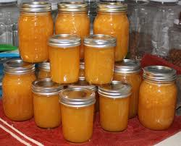
2 med. Cantaloupe, cut in pieces size of your thumb
1 (No. 2 1/2) can crushed pineapple
2 oranges
2 pkg. pectin
Sugar

Cut cantaloupe in pieces the size of your thumb. Combine with drained crushed pineapple, 2 oranges, ground peeling and all. Add 2 packages pectin. Add sugar; measure and add same amount of sugar as you have fruit. Cook until you have a thick syrup. Put into bottles and seal.

